

HPE FAST Performance Test Naming Standard

Author: Kong, Lian

Document Revision History
Ver. No. | Ver. Date | Prepared By | Reviewed By | Approved By | Affected Section & Summary of Change | PIF No.
1.0 | 10-04-2017 | Kong, Lian |  |  | Initial baseline document.
1.1 | 27-04-2017 | Kong, Lian |  |  | Update ‘Test Case/Script Name’
Table of Contents
1. Introduction 4
1.1. Scope and Purpose 4
2. Definitions and Abbreviations 4
3. Naming Conventions 4
3.1. Test Script Declaration 4
3.2. Test Case/Script Name 5
3.3. Transaction Name 5
3.4. Parameter, Variable Name 6
3.5. Constant Name 6
3.6. Test Result file/folder Name 6
3.7. Function Name 6

- Introduction
  - Scope and Purpose
This document describes the general guidelines and standards used in performance test.
- Definitions and Abbreviations
Abbreviation | Meaning
LR | LoadRunner
PC | Performance Center
ALM | Application Lifecycle Management
- Naming Conventions
Providing a standard for naming test case declaration, test steps, parameter, functions, transaction and etc makes your projects and code easier to follow by other programmers following the same standard.
  - Test Script Declaration
Each test script must include a standard file header. The file header contains the name of the module, description, author, and version history. The format of the standard file header:

/***************************************************************************************************************
Header Information
Script Name : HPE_Apttus_QuotetoOrder_AgreementtoQuotetoOrder_E2E
Created On : 3/27/2017
Created By : lian.kong@hpe.com
Referred Test case : HPE_Apttus_QuotetoOrder_AgreementtoQuotetoOrder_E2E
Transactions covered :
Target Application : https://test.salesforce.com/ SIT
Purpose : Create opportunity, create Agreement and then generate order
File Path :
Test Data Files Used :
Note:
1. In order to print out the detail error msg, please check 'Continue on Error' in 'Run-Time-Setting -> Miscellaneous';
/***************************************************************************************************************
Version : V1.0
Revision Date : 3/27/2017
Revised By : lian.kong@hpe.com
Changes : Initial Version
****************************************************************************************************************/

Example:
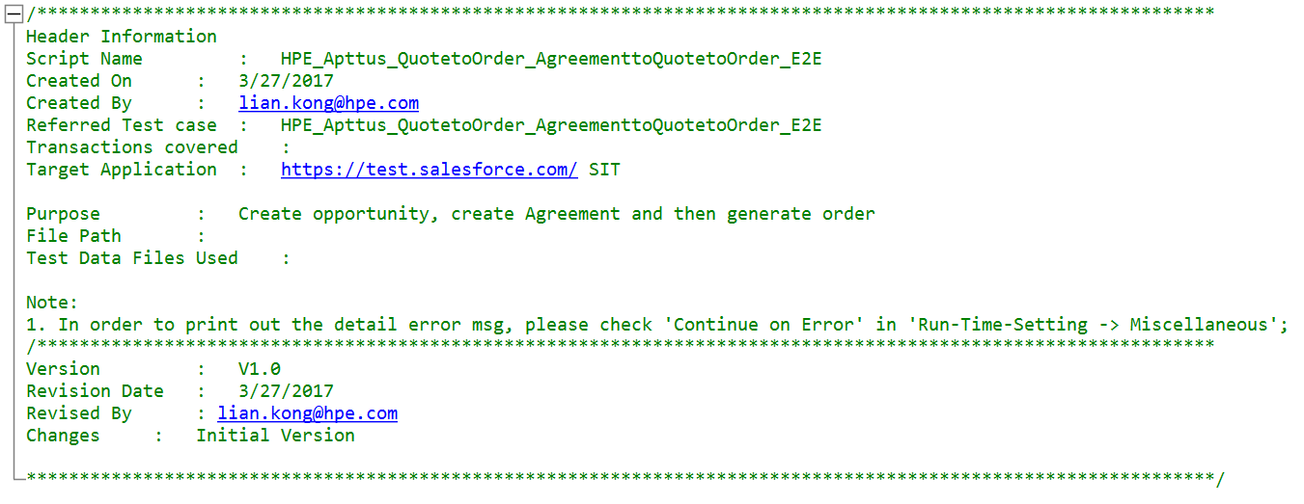
  - Test Case/Script Name
Name of LoadRunner script should be the same as test case in ALM.
<EnvironmentName>_<ApplicationName>_<BusinessTransaction>_<Test Case Simple Description>
Description is mixed by several words without underscore, and the first letter of each word is uppercase.
Simple description should be less than 20 words.
Note: Usually, the test case Name was provided by DELOITTE (Jain, Sameer), if not please confirm with Sameer.
Examples:
SIT_Apttus_QuotetoOrder_AgreementtoQuotetoOrder
LNP_Apttus_QuotetoOrder_AgreementtoQuotetoOrder
SIT_NetsuiteUI_RecordtoReport_CreateJEByCSVImport
LNP_NetsuiteUI_RecordtoReport_CreateJEByCSVImport
  - Transaction Name
Transaction name is used in LoadRunner script.
<TestCase/ScripName>_<Order Number>_<Transaction Simple Description>
Description is mixed by several words without underscore, and the first letter of each word is uppercase.
Test Case Simple Description is the same as #3.2 above.
Simple description should be less than 20 words.

Example:
SIT_Apttus_QuotetoOrder_AgreementtoQuotetoOrder_01_HomePage
SIT_Apttus_QuotetoOrder_AgreementtoQuotetoOrder_02_Login
SIT_Apttus_QuotetoOrder_AgreementtoQuotetoOrder_03_GotoOpportunity
  - Parameter, Variable Name
Parameter and Variable names are constituted with the type one or more words. For ease to definition, the first letter of each word is uppercase.

The words should use the "noun" + “noun".
Example:
UserName
Password
ProductName
AccountName
Env_HomePage
Env_SIT
Env_Content
Env_Apttus_Integration

  - Constant Name
Constant name use all uppercase letters, between words defined by an underscore, such as: “DELIMITER”, “MAX_BUFFER”.

  - Test Result file/folder Name
The test result should be zip(not rar or 7zip) package which contains “.lra” file.
<Release version>_<Environment Name>_<Test Case Name>_<Test Date>_<RoundOrder>
Test Case Name is the same as #3.2 above.
Agent is optional.

Example:
Sprint2_SIT_ HPE_Apttus_QuotetoOrder_AgreementtoQuotetoOrder_E2E _20170410_Round1
Sprint2_SIT_ HPE_Apttus_QuotetoOrder_AgreementtoQuotetoOrder_E2E _20170410_Round2

  - Function Name
All codes should contain a degree of commenting to lend clarity to the processes taking place in the functions this is not only useful for any future development or enhancement that may take place but provides useful reference for the current developer. The function which developed by our self should flow the naming standard as below,

lr_<Department Name>_<Project Name>_<Function Description>

Example:
lr_HPE_FAST_RegNavigateUrl
lr_HPE_FAST_FormatNavigateUrl

    - Comments of variables.

Comments must be added for each function then others can easily understand how to use it.

The comments should define the parameter and explain the function.

Example:

/*
lr_TCoE_DES_GetCheckItem: this function is used to get the actual checkinformation from server response.
*pCheckItem: this parameter stands for the check information, such as "Message", "Format", "Itemname"...
*pLB: input the left boundary for "web_reg_save_param" function.
*pRB: input the right boundary for "web_reg_save_param" function.
*pRel_Frame_ID: input the Frame_ID for save error page, we usually use "1".
*pFlags: this is a flag determine the search condition and if need ingnore_redirections or not. We usually use "30".
*/

void lr_TCoE_ESM_GetCheckItem(char *pCheckItem, char *pLB, char *pRB, char *pRel_Frame_ID, char *pFlags).

